**The Game of Life**

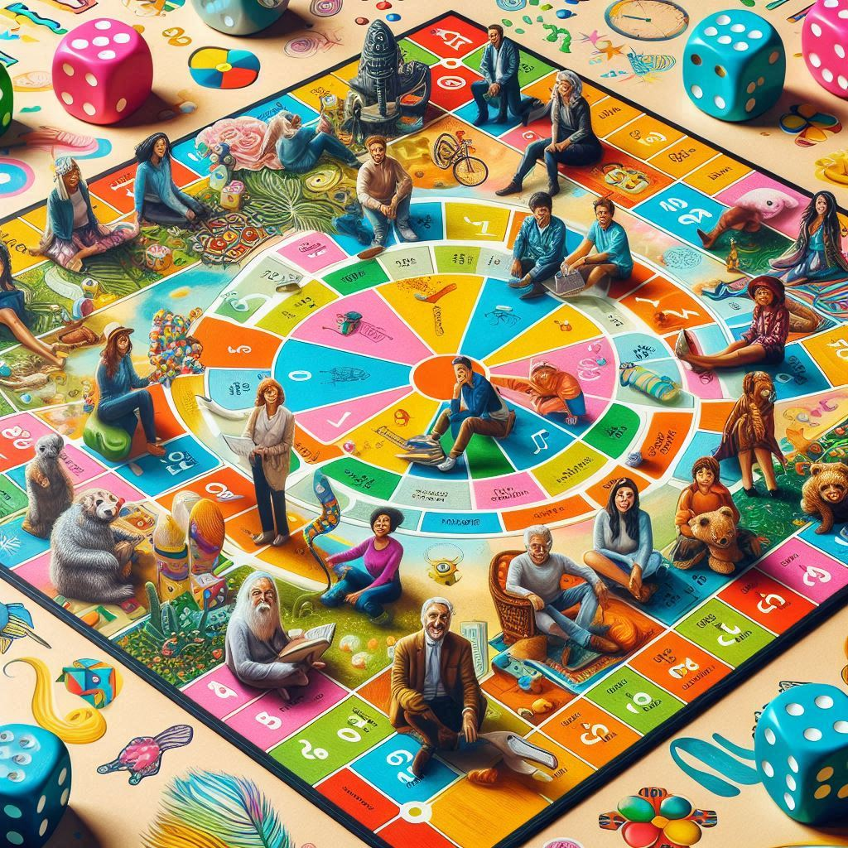

**Description:** A board game that simulates a person's journey through life.

**How to Play:** Players move through different stages of life, making decisions about career, family, and finances.

**Location:** Indoor

**Things Needed:** Game of Life board, cards, tokens

**Number of Players:** 2 to 6